

ITA_User Instruction Manual

Export/Import

*－*Version 1.9*－*

Copyright © NEC Corporation 2019. All rights reserved.

Disclaimer

All the contents of this document are protected by copyright owned by NEC Corporation.

Unauthorized reproduction or copying of all or part of the contents of this document is prohibited.

The contents of this document are subject to change without prior notice in the future.

NEC Corporation is not responsible for any technical or editorial errors or omissions in this document.

NEC Corporation do not guarantee accuracy, usability, certainty of the content in this document.

Trademark

* Linux is registered trademark or trademark of Linux Torvalds, registered in the U.S. and other countries.
* Red Hat is registered trademark or trademark of Red Hat,Inc. Registered in the U.S. and other countries.
* Apache, Apache Tomcat, and Tomcat are registered trademarks or trademarks of the Apache Software Foundation.
* Ansible is registered trademark or trademark of Red Hat,Inc.
* AnsibleTower is registered trademark or trademark of Red Hat,Inc.

The names of other systems, company name and products mentioned in this document are registered trademarks or trademarks of their respective companies.

The® mark and TM mark are not specified in this document.

※ 「Exastro IT Automation」 is written as 「ITA」 in this document.

**Table of Contents**

Introduction **エラー! ブックマークが定義されていません。**

1 Export/Import overview **エラー! ブックマークが定義されていません。**

1.1 Export/Import Menu **エラー! ブックマークが定義されていません。**

1.1.1 Functions **エラー! ブックマークが定義されていません。**

1.1.2 Modes **エラー! ブックマークが定義されていません。**

1.1.3 Examples **エラー! ブックマークが定義されていません。**

1.2 Excel bulk export/import 8

1.2.1 Functions **エラー! ブックマークが定義されていません。**

2 Export/Import menu configuration **エラー! ブックマークが定義されていません。**

2.1 Menu list **エラー! ブックマークが定義されていません。**

3 How to use **エラー! ブックマークが定義されていません。**

3.1 Export menu **エラー! ブックマークが定義されていません。**

3.2 Import menu **エラー! ブックマークが定義されていません。**

3.3 Export/import menu list **エラー! ブックマークが定義されていません。**

3.4 Excel bulk export **エラー! ブックマークが定義されていません。**

3.5 Excel bulk import **エラー! ブックマークが定義されていません。**

3.6 Excelbulk export/import list 20

Introduction

This manual explains about the ITA Export/Import function.

# Export/Import overview

This chapter will explain the Export/Import function, its modes, as well as show some examples.

## Export/Import function

### Functions

To Export/Import, select the menu you want to move and then transfer them my overwriting the data as menu units.

ITA server A

Kym file

Import

Export

Kym file

ファイル

ITA server B

**Selected menus**

Menu A

Menu Ｂ

ﾒﾆｭｰC

Menu C

Menu Ｂ

ﾒﾆｭｰC

Menu C

Menu A

### Modes

The export function consists of 2 modes.

1. **Environment migration**

Exports all the data of the selected menus. It will overwrite all the data of the Import destination.

**All of the data in Menu A will be exported.**

**ITA Server B**

**ITA Server A**

**Menu A**

**Menu A**

**Kym**

**file**

**Data １**

**Data ２**

**Data １**

**Data ３**

**Data ２**

**Data ３**

1. **Time specification**

Exports only data last updated after a specified time.

If the unique items (ID, No, etc.) overlap, the exported data will take priority over the imported data.

Example：If the following date/time is set: 2021/01/02 17:00

**Only Data 2 and Data 3, whose “Last updated” date was after the specified time, will be exported.**

**Data 2 and 3 will be added**

**ITA Server A**

**Menu A**

**Data 1 2021/01/01 17:00**

**Data 2 2021/01/02 17:00**

**Data 3 2021/01/03 17:00**

**ITA Server B**

**Menu A**

**Data 1 2021/01/01 17:00**

**Kym**

**File**

**Data 2 2021/01/02 17:00**

**Data 3 2021/01/03 17:00**

### Example

This example assumes that two environments, ITA Server A and ITA Server B, will be used for the function.

**Pattern ①：Replicating the environment**

All the data registered to ITA Server A will be replicated onto ITA Server B.

Procedure

1. Export all of the data in ITA Server A in using the Environment Migration mode.
2. Take the exported data from step 1 and import it to ITA Server B.

※After importing, users can register and change the data in ITA Server B.

After that, trying to move the same data from ITA Server A again might cause inconsistency errors, so we recommend not doing so.   
※We do not recommend moving data from/to both sides, as this might cause inconsistency errors.

**3. Register and change data**

**1.Input and test data**

※After importing, users can register and change the data in ITA Server B.

After that, trying to move the same data from ITA Server A again might cause inconsistency errors, so we recommend not doing so.

**ITA Server B**

**ITA Server A**

**2.Move all the data**

**ITA**

**ITA**

**Menu A**

**Menu A**

**Menu B**

**Menu B**

We do not recommend moving data from/to both sides, as this might cause inconsistency errors.

**Pattern ②Separate Data input server and Executing server.**

If you want to have 2 servers. 1 server for data entry and testing and 1 for executing operations.

Procedure

1. Export all of the data in ITA Server A in using the Environment Migration mode.
2. Take the exported data from step 1 and import it to ITA Server B.
3. Whenever there data in ITA Server A changes, use the Time Specification mode to import any changed data to server B.

※If you already know that you are going to move data multiple times,

Registering/Changing the data is not recommended, as it might cause inconsistency issues. However, executing operations has not effects.

※When moving data while an operation is running on Server B, make sure to use the Time specification to move only the data that as changed in order to prevent the import having any effect on the running operation.

※We do not recommend moving data from/to both sides, as this might cause inconsistency errors.

**3. Register and change data**

**1.Input and test data**

※After importing, users can register and change the data in ITA Server B.

After that, trying to move the same data from ITA Server A again might cause inconsistency errors, so we recommend not doing so.

**ITA Server B**

**ITA Server A**

**2.Move all the data**

**ITA**

**ITA**

**Menu A**

**Menu A**

**Menu B**

**Menu B**

We do not recommend moving data from/to both sides, as this might cause inconsistency errors.

## Excel bulk export/import

### Function

The Excel bulk export/import allows users to use the downloadable menu files (Excel or CSV) and export/import them as zip files.

For information regarding what files are downloadable, please see “Exastro-ITA_User_Instruction_Manual_Basic_console"

Only menus that the user has permission to see or maintain can be exported.

Only menus that the user has permission to maintain can be imported.

# Menu and screen configuration of Export/Import

This chapter explains the Export/Import function menu and screen configuration.



## Menu List

The Export/Import menus are as follows.

**Table 2-1 ITA Menu list**

|  |  |  |  |
| --- | --- | --- | --- |
| **No** | **Menu group** | **Menu / Screen** | **Description** |
| 1 | Export/Import | Export menu | Exports menu data. |
| 2 | Import menu | Imports menu data. |
| 3 | Export/Import menu list | Manages the status of the exports executed in [Export menu] and imports executed in [Import menu]. |
| 4 | Excel bulk export | Takes downloadable data and compresses it into a zip file and exports it. |
| 5 | Excel bulk import | Imports data compressed in zip files. |
| 6 | Excel bulk export/import list | Manages the status of exports executed in [Excel bulk export] and imports executed in [Excel bulk import]. |

# Function and operation method

## Export Menu

Export data registered in the ITA system in each menu.

※When moving data to another ITA environment, the integrity of data may corrupt if the whole menu is not moved together.

1. Select the mode and abolition data to export

List of Modes and Abolition data are displayed below.

Table 3-1 Mode list

|  |  |
| --- | --- |
| **Name** | **Description** |
| Overwrite | All existing data will be deleted and overwritten during import. |
| Postscript | Only data different to the existing data will be added during import.  If the unique key (ID, No. etc) is duplicated, the existing data will keep its priority. |

Table 3‑2 Abolition data list

|  |  |
| --- | --- |
| **Name** | **Description** |
| Normal | Export all normal data. |
| Without disuse data | Export without disuse data. |

1. Select the menu to export

C:\Users\113414A009FT8\Desktop\20160220131903.png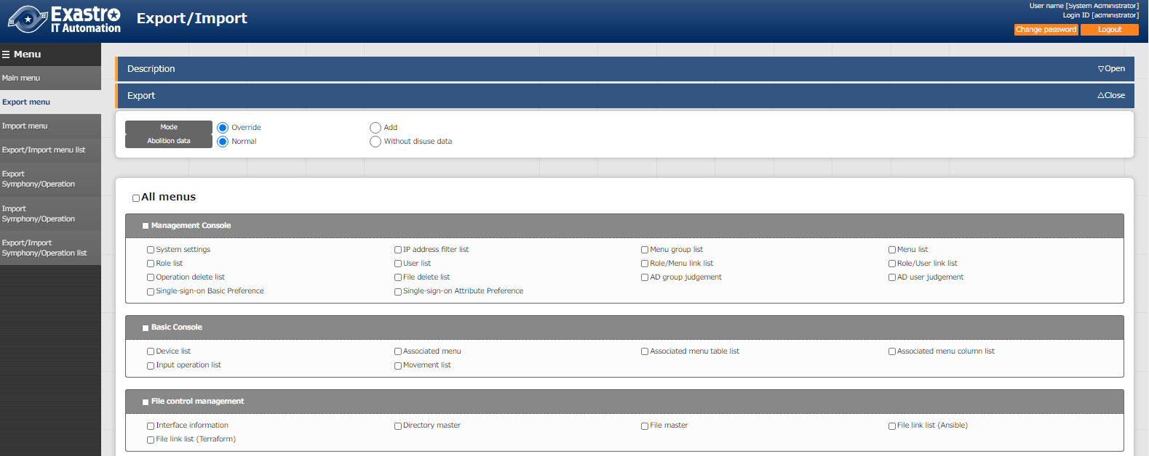



Figure 3‑1 Export menu screen (1)

1. Click the export button after selecting the menu.

The execution number of export operation is displayed, so please check the status of execution in the "Export/Import menu list" screen.



Figure 3‑2 Export menu screen (2)

## Import menu

Import the data exported in [Export menu] menu.

1. Select the file to be imported then click the [Upload] button. 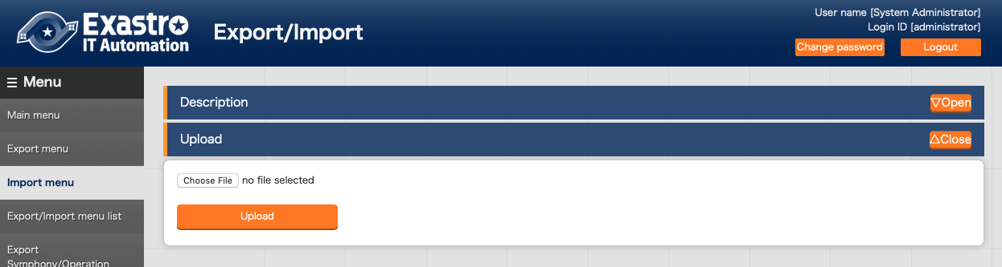

Figure 3‑3 Menu import screen (1)

1. The list of the menu in the imported file is displayed. Select the menu to import then click the [Import] button. Please click [Import (without discarded data)] to import the menu without discarded data.

The menu whose checkbox is checked will be imported.  
Please uncheck the menus that are not needed to be imported.

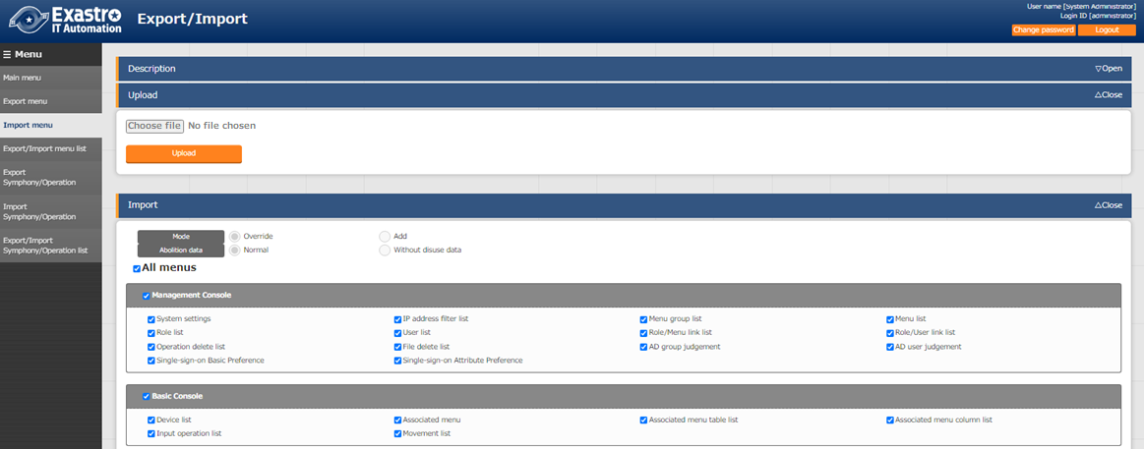

C:\Users\113414A009FT8\Desktop\20160220131903.png

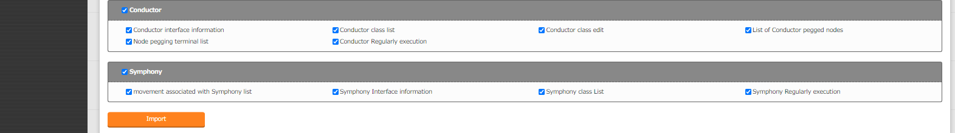

Figure 3‑4 Import menu screen(2)

1. Move to the registration menu. Users can check the status of the migration in the [Export/Import menu list] by clicking the [Export/Import data list] button.

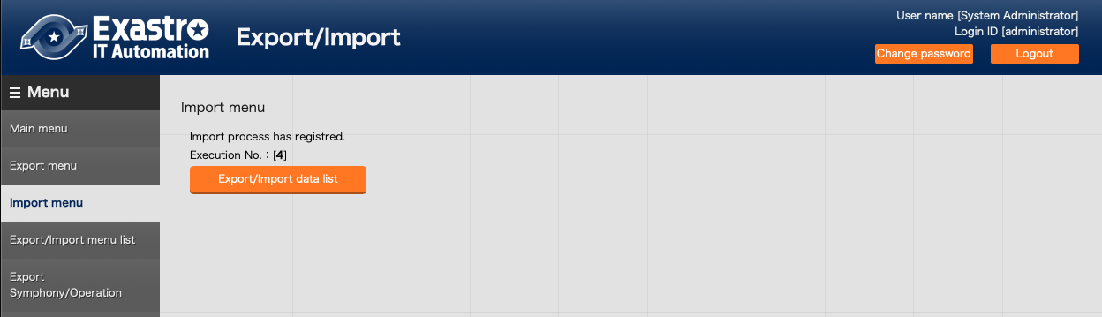

Figure 3‑5 Menu import screen(3)

## Export/Import menu list.

This menu manages any exports and imports executed in their respective menus as well as their status and data. Only data from exports/imports that the logged in user executed will be displayed..

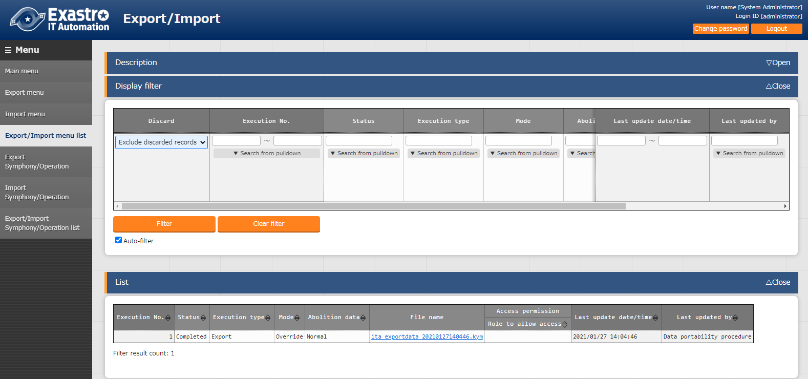

Figure 3‑6 Export/Import menu list

Table 3‑3　List screen item list（Export/Import menu list）

|  |  |
| --- | --- |
| Item | Description |
| Execution No. | Auto generated unique number. |
| Status | Changes in the order of "Unexecuted", "Executing", "Completed".  If error occurred during execution, the status will become "Completed (error)". |
| Execution type | Export・・・Export menu  Import・・・Import menu |
| Mode | "Overwrite" or "Postscript" will be displayed. |
| Abolition data | "Normal" or "Without disuse data" will be displayed. |
| File name | If the export status says "Completed", the exported data will be displayed in the "File name" column. The file can then be downloaded for further use.  Imported data will be displayed in the "File name" column. |
| Execution user | Displays the user that started the export/import process.  The item “Execution user” is added when updated from version 1.7.2 to 1.8.0.  Data is only displayed if the “Execution user” field is blank or if the logged in user is the execution user. |

## Excel bulk export

Collects downloadable data from the different menus and exports them as a zip file.

1. Choose what abolished data the user is exporting.

The abolished information list is as following.

Table 3‑1 Abolished information list

|  |  |
| --- | --- |
| **名称** | **Description** |
| All records | Exports all data |
| Exclude abolished data | Exports all data excluding abolished data. |
| Abolished data only | Exports only abolished data。 |

1. Select what menus to export

Data only the user has permission to see or maintain can be exported.

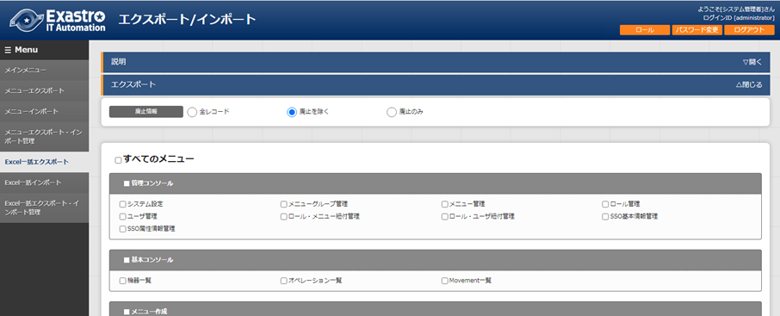C:\Users\113414A009FT8\Desktop\20160220131903.png

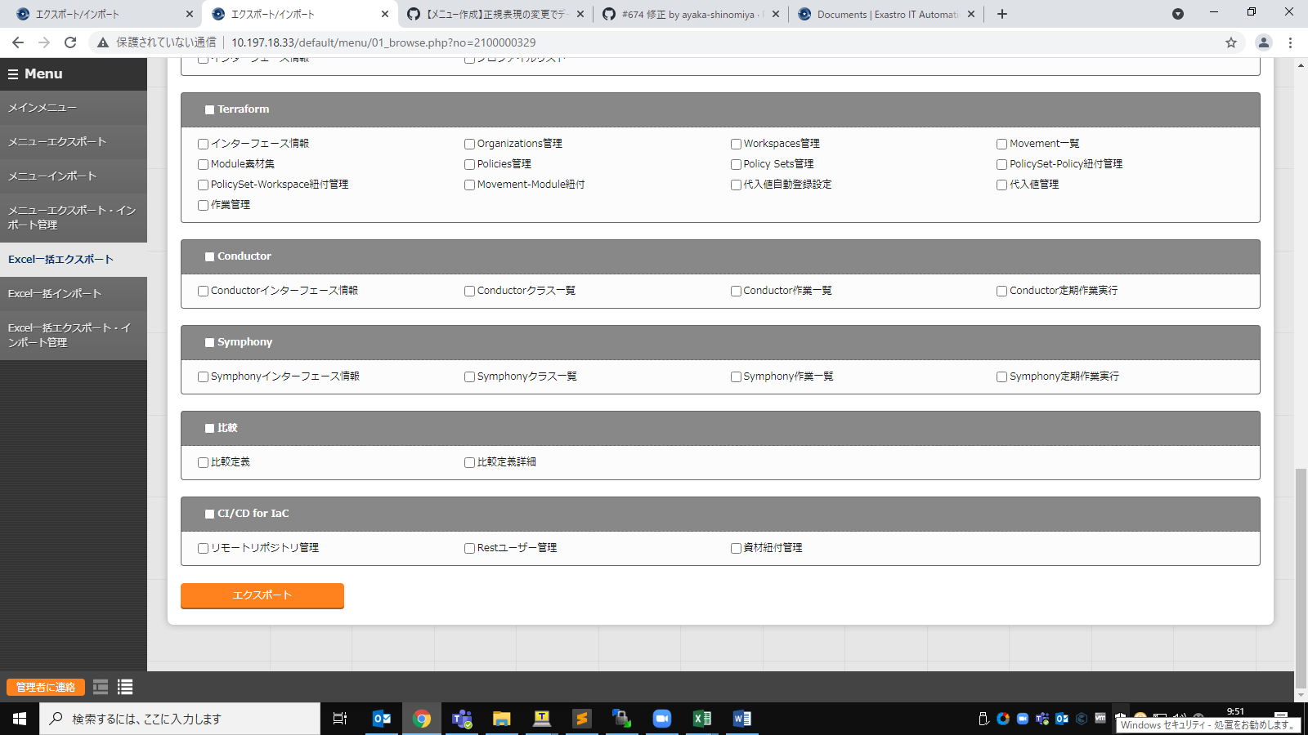

Figure 3‑1 Excel bulk export screen(1)

1. After selecting which menus to export, press the “Export” button.

The export process’ execution number will be displayed. Use this number to see the status of the process in the “Excel bulk export/import list” menu.

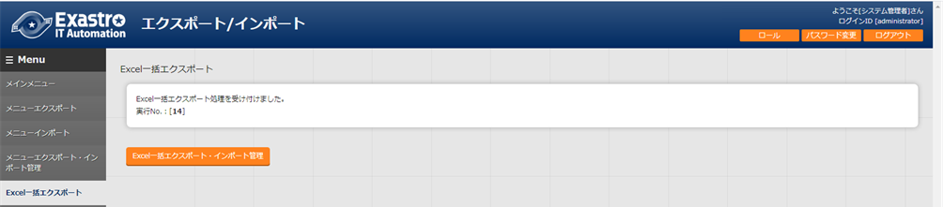

Figure 3‑2 Excel bulk exportscreen(2)

1. The contents of export files are as displayed below

File configuration

|  |
| --- |
| ITA_FILES_YYYYMMDDhhmmss.zip …①  ├─ MENU_LIST.txt …②  ├─ 2100000002_Basic console …③  │　 ├─ user list_20210708235958.xlsx …④  │ └─ menu list_20210708235959.xlsx …④  ├─ 2100000003_Basic console  │ ├─ Device list_20210708235858.scsv …④  │ └─ Device list_20210708235859.xlsx …⑤  └─ editBaker …⑥ |
|
|

|  |  |  |  |
| --- | --- | --- | --- |
| **No** | **Name** | **Type** | **Description** |
|  | File name | File | The file name is:  “ITA_FILES_YYYYMMDDhhmmss.zip” |
|  | MENU_LIST.txt | txt | List of menu ids and file names. |
|  | Menu group folder | Folder | One folder is created per menu group.  The name of the folder is ”Menu group ID_Menu group name』”  The folder name will only contain the first 200 letters of the menu name. |
|  | Download file | xlsx/scsv | Output in either excel format or in CSV format. (If the number of menus exceeds the "Excel maximum line number" in the "Menu list", the file will be input in CSV format.)  The files will be put under the file’s respective menu group folder. |
|  | Proprietary format editing Excel creation materials | xlsx | Materials used when editing CSV files.  Will only be output if the output files are in CSV format. |
|  | editBaker | Folder | Excel creation tool used to edit proprietary files.  Will only be output if the output files are in CSV format. |

## Excel bulk import

Edit the data exported in the “Excel bulk export” menu and import it.

1. Edit zip file

(1)Create a list over the menus to import.

Users can edit the MENU_LIST within the export file in order to edit what menus to import.  
The MENU_LIST.txt file includes the Menu ID and file names selected when the file was exported.

Input a “#” mark in front of the line in order to comment it out.

The name will be in the following format

Menu ID: File name

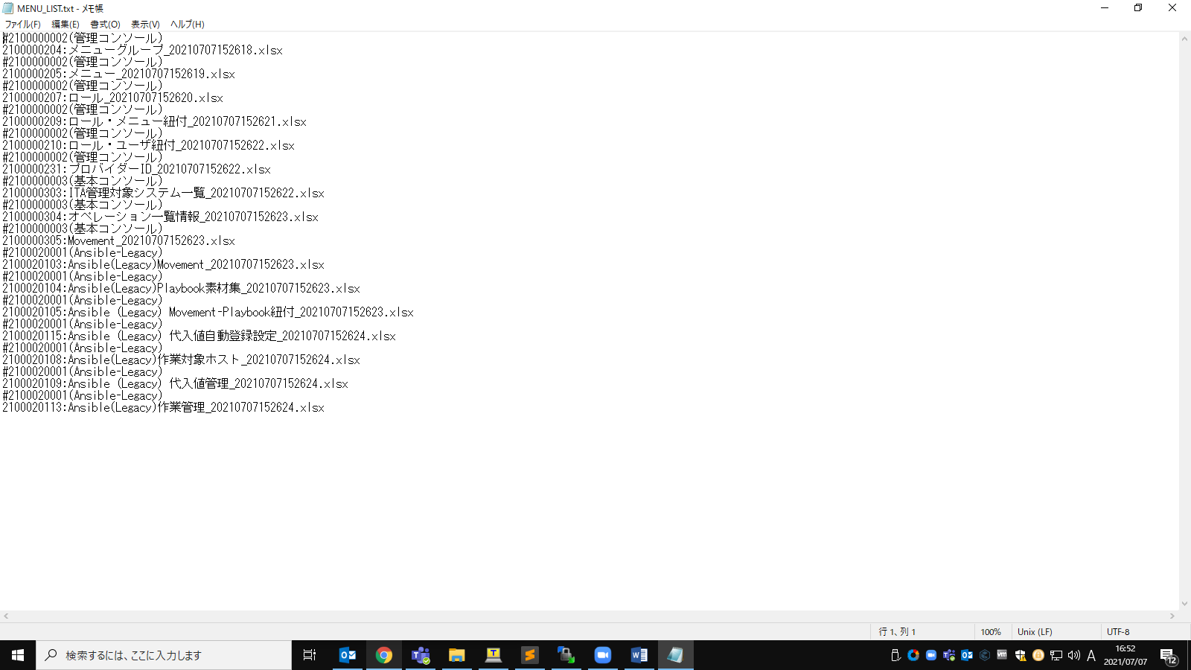

Figure 3‑3 MENU_LIST.txt

※Users can also select what menus to import in the “Excel bulk import menu”.

(2) Edit the import file (Excel or CSV format)

(3) Compress the edited files.

The following files are required in order to import.

・MENU_LIST.txt

・Import file (Excel or CSV format)

1. Import process

Press the "Select file" button and upload the zip file to import.

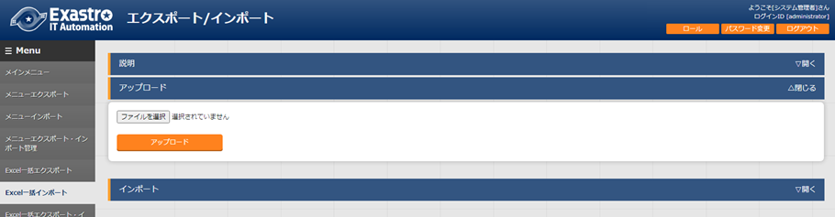

Figure 3‑4 Excel bulk import screen(1)

The menus within the import file will be displayed in a list. Select which menus to import and press the "Import" button.

All menus with their checkbox ticked will be imported.

The files will be imported in the order they are listed in the MENU_LIST.TXT file.

Untick the checkbox for menus that will not be imported.

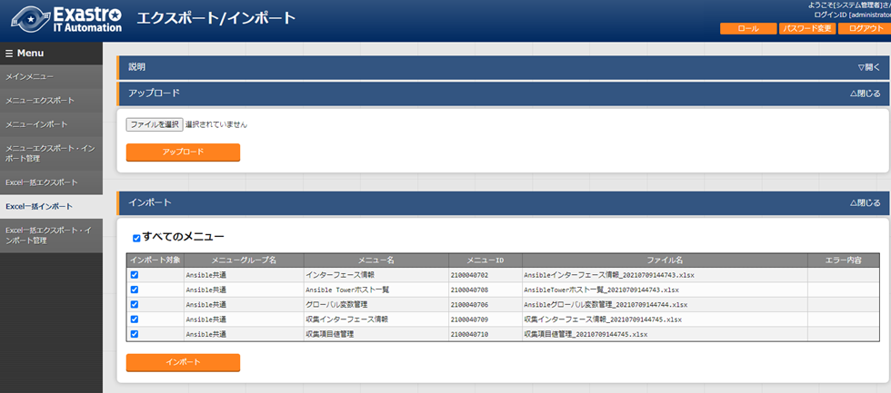

Figure 3‑5 Excel bulk import screen(2)

If the following conditions are met, the import process will end up in an error and the checkboxes will be deactivated.

１．If two of the same IDs are specified in the MENU_LIST.txt file

２．If there are two menus are set to a single file in the MENU_LIST.txt file

３．If the MENU_LIST.txt file contains text written in the wrong format

４．If a non-existent menu ID is written in the MENU_LIST.txt file

５．If a non-existent file is specified in the MENU_LIST.txt file

６．if there are two items with the same name in different folders in the MENU_LIST.txt file

７．If the login user doesn’t have "can maintain" for the menus the user wants to import.

* + - 1. After importing, the user will be moved to a confirmation screen. Pressing the "Excel bulk export/import list" button will move the user to the "Excel bulk export/import list" menu where they can see the status of the import process.

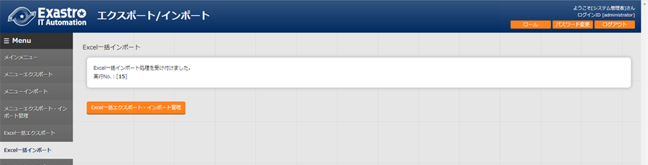

Figure 3‑6 Excel bulk import screen(3)

## Excel bulk export・Import list

Manages the status of export/import processes started in the "excel bulk export/excel bulk import" menu. Only processes started by the logged in user will be displayed.

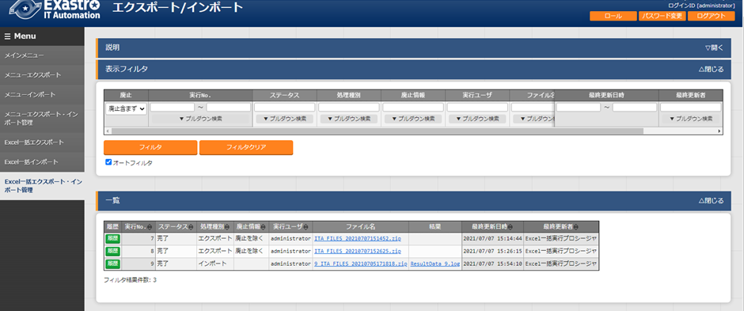

Figure 3‑7 Excel bulk export・Import list screen

Table 3‑2 Item list（Menu export・Import list）

|  |  |
| --- | --- |
| **Item** | **Description** |
| Execution No. | Auto generated unique number. |
| Status | Changes in the order of "Unexecuted", "Executing", "Completed".  If error occurred during execution, the status will become "Completed (error)". |
| Process type | export・・・Excel bulk export  Import・・・Excel bulk import |
| Abolished information | Displays what abolished information got imported/exported. |
| Execution user | Displays the username of the user that started the export/import process. |
| File name | If the export status says "Completed", the exported data will be displayed in the "File name" column. The file can then be downloaded for further use.  Imported data will be displayed in the "File name" column. |
| Result | Displays a downloadable text file that contains information regarding the import process.  The file can then be downloaded for further use. |

* + - 1. The following is an excerpt from an import result file.

Information for all the imported files will be output.

|  |
| --- |
| 2100000003_Basic console:2100000501_Link menu  InputFile:AnsibleLinkMenu_20210708023537.xlsx  Registered: 0  Updated: 2  Abolished: 1  Restored: 1  Error: 0  2100000002_ManagementConsole:2100000208_UserList  InputFile:User_20210624111008.xlsx  Registered: 0  Updated: 0  Abolished: 0  Restored: 0  Error: 1  Line:11 username: must fill the following requirements. (Character limit (Excluding tabs and lines) Max:270 bytes/Min:1 byte  This item is required. (Item:username)  2100000003_BasicConsole:2100000327_ERFigureMenuList  InputFile:ERFigureMenuList_20210708023538.xlsx  This menu does not have an excel edit file. |
|
|